Lab3_2
1-=>j
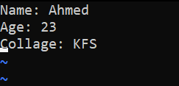
2-=>k
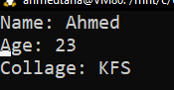
3-=>/Age
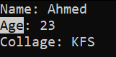
4-=>:5
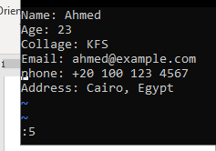
5-:=>dd inline 5
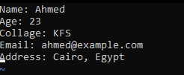
6-=> (A)
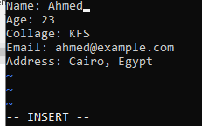
Lab 4
1-
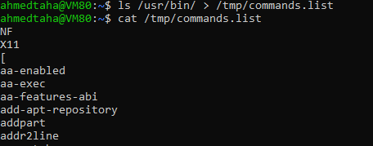

2-
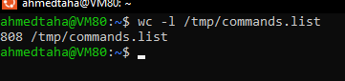
3-
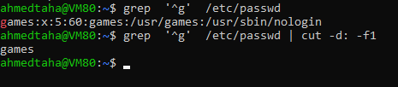
6_1-
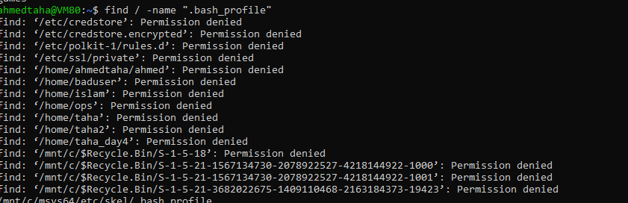
7-
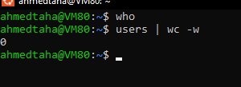
8-
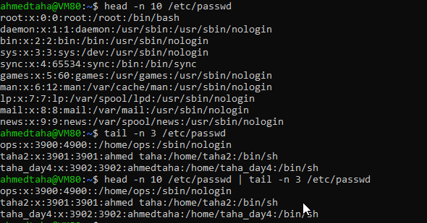

9-
1)
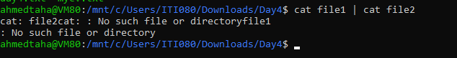
2)=> rm need files names for delete
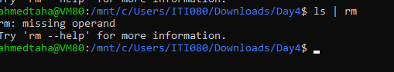
3)
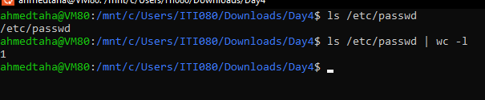
10-

11-ctrl+c
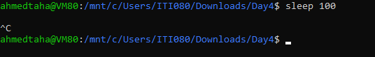
12-
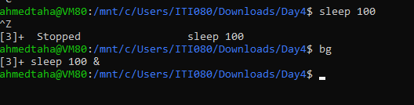
13-
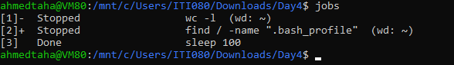
14-
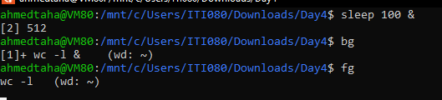

15-
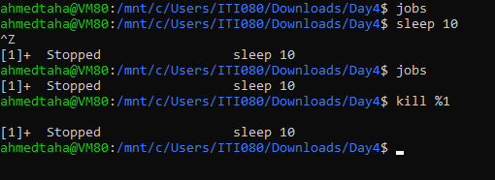
16-
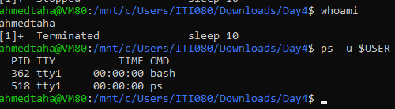
17-
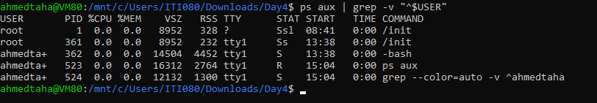
18-
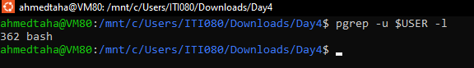
19-pkill -u $USER
